Linux commands end to end cheat sheet

Description: Display the current user account
Command: Display the current user account
Example: Running whoami in the terminal will show your username,like sulaiman ( In my case its sulaiman)

Describtion: List file and directories in the current directory
Command: List file and directories in the current directory
Example: ls display file and folder and ls –l provides detailed information
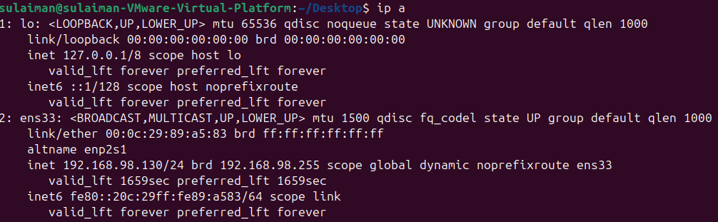
Description: List your ip address and network interface.
Command: List your ip address and network interface.
Example: ip a show all network interfaces with their ip addresses

Description: read and displays the contents of text file.
Command: Read and display the contents of text file.
Example: cat file.txt shows the contents of file.txt

Description: Display the current working directory.
Command: Display the current working directory
Example: Running pwd shows your current path, like /home/sulaiman/Desktop

Command: mkdir
Description: creates a new directory folder
Example: mkdir folder create a folder named folder in the current directory

Description: Remove an empty directory
Command: rmdir
Example: rmdir myfolder deletes the folder if its empty

Description: Delete file or directories.
Command: RM
Example: rm file1.txt remove a file. Use rm –r foldername to delete a folder and its contents.

Command: cp
Description: Copies file or directories
Example: cp file.txt /home/sulaiman/Downloads/ copes file.txt to the Downloads
Command: mv
Description: Movies or rename files and directories
Example: mv file file.txt /home/sulaiman/Desktop/file1.txt moves the file mv oldname.txt newname.txt rename it

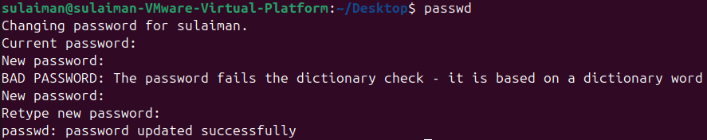
Command: passwd
Description: Used to change the password of the user account
Example: Typing passwd and following the prompts will allow you to change your password.

Description: create empty file
Example: touch new.txt create an empty file named new.txt

Command: pwd
Description: prints the current working directory ( shows which folder you are in)
Example: pwd might return /home/sulaiman.

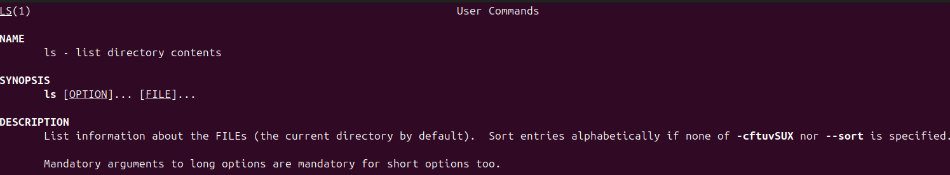
Command: man
Description: opens the manual ( system documentation for commands)
Example:man ls show the manual pae for the ls command

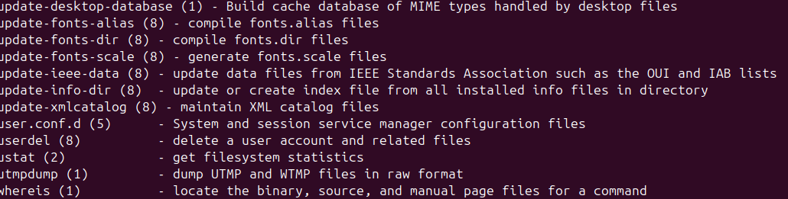
Description: searches manual pages descriptions for keywrds (like man –k)
Example: aprops “ list file” might return command related to listing file

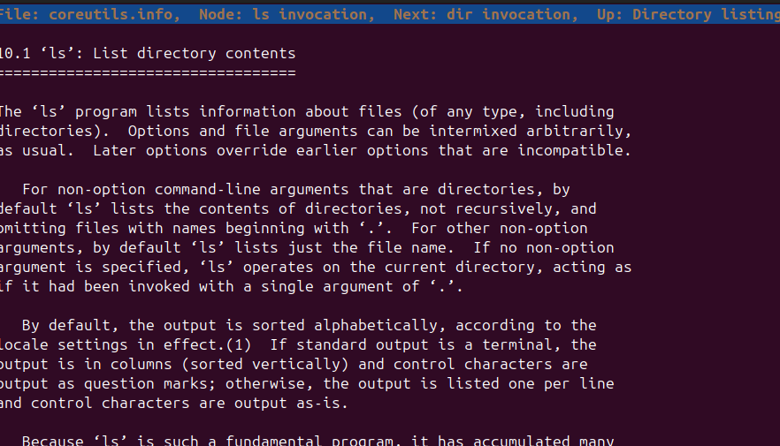

Command: pinfo
Description: Provides additional command information similar to man but for formatted differently
Example: pinfo ls give detailed info about ls command
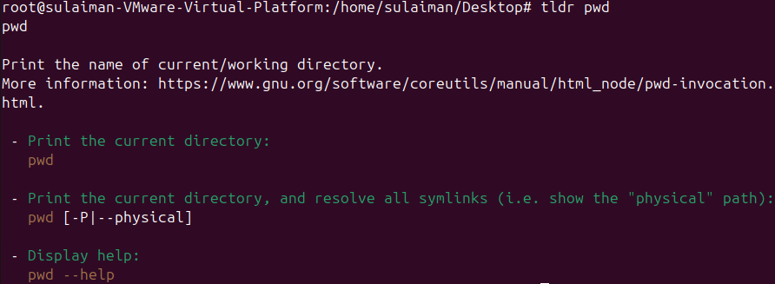
Command: tldr
Description: shows simplified , example-based command help ( short cheats)
Example: tldr pwd show concise usage example for tar

Essential File Management Tools Commands
Command: ls
Example: ls /home/user/Desktop
Description: list file and directories within a specified
Command: cp
Example: cp file.txt file2.txt
Description: copies files from one location to another.
Used to make duplicates of file
Command: mkdir
Example: mkdir new_directory ( ur folder name )
Description: create a new directory (folder)
Command: rm
Example: rm new.txt
Description: Delete a file. Use rm –r to remove directories recursively
Command: mv
Example: mv file1.txt file.txt
Description: moves or renames files and directories
Command: rmdir
Example: rmdir myfolder
Description: Remove an empty directory and if (force), as in rm -rf directory_name, it becomes a powerful command that can delete directories)

Advanced File Management Tools Commands

